

*National University of Computer & Emerging Sciences*

*Islamabad*



**Digital Logic Design Lab # 08**

***Student Name: Muhammad Ahmed Baig Reg# 20i-1884***

***Lab Section: B***

***LabTitle:***

BCD decoder to Seven segment LED display

***Objectives:***

To become familiar with the operation of 7-segment display.

***Equipment Required:***

* DEV-2765E Trainer Board
* 7448 BCD to 7-segment (common-cathode) decoder
* Common-cathode 7-segment LED (single and double digit) Display

**Seven Segment LED Display:**

The numbers from 0 to 9 can be shown using a 7–segment LED display unit. This unit shows one decimal digit using 7 LED segments to form the numbers from 0 to 9. These 7-segments are a, b, c, d, e, f, g

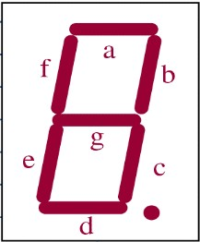

A 7448 chip can be used to construct the pattern of segments for each state of the counter’s 4 lines or bits. Thus, the 7448 inputs are the 4 lines from the binary counter or from the input switches of Trainer board and its outputs are the 7 lines to the 7-segment LED Display showing the state of the segments.

The 7448 is a BCD decoder so it only works for counter states between 0000 and 1001, i.e. decimal numbers 0 through 9.

***PIN CONFIGURATION:***

The pin connections of the 7448 are (pins 1-16): bcd2, bcd3, free, free, free, bcd4, bcd1, ground, e, d, c, b, a, g, f, +5v; where bcd4 is the slowest line of the binary counter to change and bcd1 is the fastest. Pins are numbered counter-clockwise from top left of the 16 pin chip.

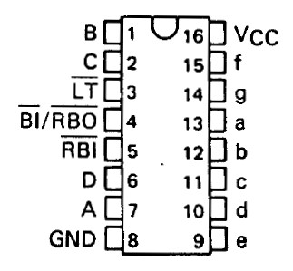

7448-IC Pin Configuration

The pin connections of the common-cathode 7-segment single digit display are below:

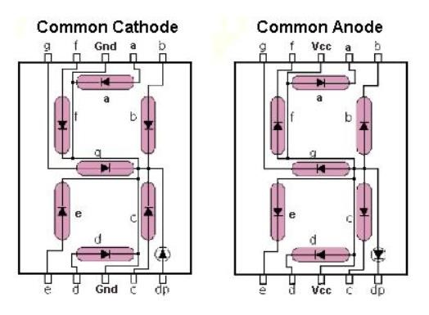

The pin connections of the common-cathode 7-segment double digit display are below

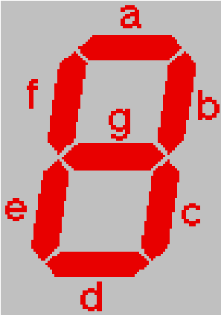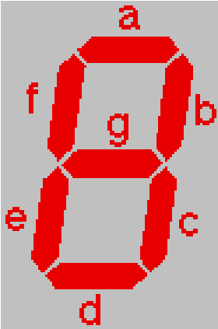

D

P

d

e

c

D

P

d

e

c

g

g

a

b

f

G

N

D

a

b

GN

D

f

**BCD-TO-SEVEN SEGMENT DECODER/**

**DRIVER (7448)**

16

8

Vcc

GND

D

0

D

1

D

2

D

3

7

1

2

6

a

b

c

d

e

f

g

13

12

11

10

9

15

14

LT

BI

/

RBO

RBI

3

4

5

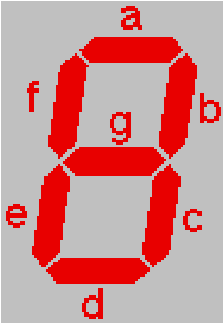

GND

f

g

a

b

c

d

e

DP

***7448***

A

B

C

D



***Procedure***

1. Connect the trainer with the power supply
2. Mount the BCD to 7-segment driver IC 74LS48 on the trainer board
3. Connect pins of the IC according to the diagram
4. Connect pin 16 to +5 V (Power Supply) and pin 8 to GND (Ground).
5. Apply all the combination of inputs and see the corresponding decimal digit on the 7-segment LED display.

**Truth Table**

|  |  |  |  |  |  |  |  |  |  |  |  |
| --- | --- | --- | --- | --- | --- | --- | --- | --- | --- | --- | --- |
|  | **A** | **B** | **C** | **D** | **a** | **b** | **c** | **d** | **e** | **f** | **g** |
| **0** | 0 | 0 | 0 | 0 | 1 | 1 | 1 | 1 | 1 | 1 | 0 |
| **1** | 0 | 0 | 0 | 1 | 0 | 1 | 1 | 0 | 0 | 0 | 0 |
| **2** | 0 | 0 | 1 | 0 | 1 | 1 | 0 | 1 | 1 | 0 | 1 |
| **3** | 0 | 0 | 1 | 1 | 1 | 1 | 1 | 1 | 0 | 0 | 1 |
| **4** | 0 | 1 | 0 | 0 | 0 | 1 | 1 | 0 | 0 | 1 | 1 |
| **5** | 0 | 1 | 0 | 1 | 1 | 0 | 1 | 1 | 0 | 1 | 1 |
| **6** | 0 | 1 | 1 | 0 | 1 | 0 | 1 | 1 | 1 | 1 | 1 |
| **7** | 0 | 1 | 1 | 1 | 1 | 1 | 1 | 0 | 0 | 0 | 0 |
| **8** | 1 | 0 | 0 | 0 | 1 | 1 | 1 | 1 | 1 | 1 | 1 |
| **9** | 1 | 0 | 0 | 1 | 1 | 1 | 1 | 1 | 0 | 1 | 1 |
| **10** | 1 | 0 | 1 | 0 | x | x | x | x | x | x | x |
| **11** | 1 | 0 | 1 | 1 | x | x | x | x | x | x | x |
| **12** | 1 | 1 | 0 | 0 | x | x | x | x | x | x | x |
| **13** | 1 | 1 | 0 | 1 | x | x | x | x | x | x | x |
| **14** | 1 | 1 | 1 | 0 | x | x | x | x | x | x | x |
| **15** | 1 | 1 | 1 | 1 | x | x | x | x | x | x | x |